Gravestone Photographic Resource
Monument Indexing Examples
Introduction
This document has been produced to try and help with the index of grave monuments. The GPR uses a spread sheet as the basis of the indexing and this has a number of columns in which the information for each monument is stored:
Image: this is the name of the photo image file, usually something like IMG_1234
Type: this contains the relationship code for the name specified in this particular row
Title: this is the title of the person if it is mentioned on the monument, not often given
Forenames: this is the forenames of the person
Nicknames: this is the nickname of the person
Maiden Name: this is the surname of a woman before she was married
Honour: this is any honours mention on the monument for this particular person – these honours can range from military honours such as DSO to educational qualifications such as MD or definition of a job such as MP or JP
Death: this is the year of death – just the year is needed
Age: this is the age in years if mentioned – if it is not given the system will display, where appropriate, a calculated age
Birth: this is the year of birth if mentioned– if it is not given the system will display, where appropriate, a calculated year of birth
Notes: this is where any other information given on the monument can be stored.

For each of the above mentioned fields at least one example will be shown with an associated image to help clarify the matter. To help keep the size of this document reasonable, the images have been re-sized and so are not necessarily as clear as the originals. The originals can be viewed in the examples folder.

Image Name
For this example we shall look at the grave monument of Thomas Ivory Butler from the East of the Water cemetery in Bideford, Devon, England.
This is an interesting monument in that it is double sided and so more than one image is needed:
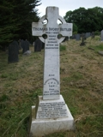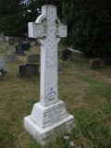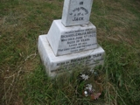
When these images were taken, the camera gave them the image names of:
IMG_449.jpg
IMG_450.jpg
IMG_451.jpg
However, so that the three images can be easily identified as a “set”, they were renamed:
IMG_449.jpg
IMG_449a.jpg
IMG_449b.jpg
On the website thumbnail copies of these images exist with the names:
449.jpg
449a.jpg
449b.jpg
On each monument display page the system reads the information about the grave and obtains the image name, in this case 449. It automatically looks for the image file (either 449.jpg or 449.JPG) and if found will display it and then look to see if there is another image with the name 449a and so on.
The spread sheet entry for Thomas Ivory Butler is as follows:
image | type | title | forename | nickname | maiden name | surname | honour | death | age | birth | notes
449 | a |  | Thomas Ivory |  |  | Butler |  | 1989 |  | 1915

All other entries for this grave monument will have the image number of 449 even if the information about them is on one of the other images within the set. For instance, the details about Jack Butler are on the back on the monument (image 449a) but his entry would be:
image | type | title | forename | nickname | maiden name | surname | honour | death | age | birth | notes
449 | a |  | Thomas Ivory |  |  | Butler |  | 1989 |  | 1915
449 |  |  | Jack |  |  | Butler |  | 1922 | 10 |  | son of Richard and Emily A Butler

Although the grave monument shows that Jack is the son of Richard and Emily, there is no indication of the relationship of any other these to the first named person on the monument.

Type
This column within the spread sheet is used to show the relationships between people mentioned on the monument.
The first entry for a new grave monument is given the type code of “a”. The system used to update the GPR database uses this “a” to generate a new grave record.
Although this entry is normally the first name on the monument, in some cases this may not be appropriate. For instance there are cases where all the relationships mentioned on the monument relate to a name mentioned further down the monument. In these cases it is often easier to choose the later name as the “first named”. This is most likely to occur with monuments from inside churches which contain lots of clear text.
The grave monument for John Bentall on the wall inside St Mary’s Church, Totnes, Devon, England is a good example of monuments that contain clear text and lots of names and relationships. In this particular case it was appropriate to use the actual first named person.
 |  |  |  | 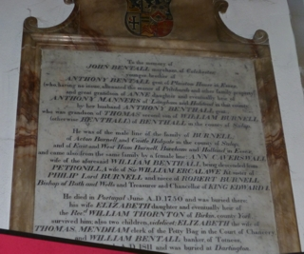
image | type |  | title |  | forename | nickname | maiden name | surname |  | honour | death |  | age | birth |  | notes
38 | a |  |  |  | John |  |  | Bentall |  |  | 1750 |  |  |  |  | merchant of Colchester - died in Portugal

Title
This field is used to show any title mentioned on the monument for this particular person. The most common is that of “Rev” (short for Reverent) and for soldier’s rank.
image | type | title | forename | nickname | maiden name | surname | honour | death | age | birth | notes
38 | a |  | John |  |  | Bentall |  | 1750 |  |  | merchant of Colchester - died in Portugal
38 | ggf6 | Sir | William |  |  | Ercalawe | Kt
38 | fl | Rev | William |  |  | Thorton |  |  |  |  | of Birkin county York
38 | sov | King | Edward 1 |  |  | Plantagenet

